Esercitazione 7.

Simulare la seguente rete e rendi possibile la comunicazione tra tutte le sottoreti presenti, compila la tabella sottostante (modifica spazi ,righe, colonne se necessario) ed etichetta tutti i dispositivi.

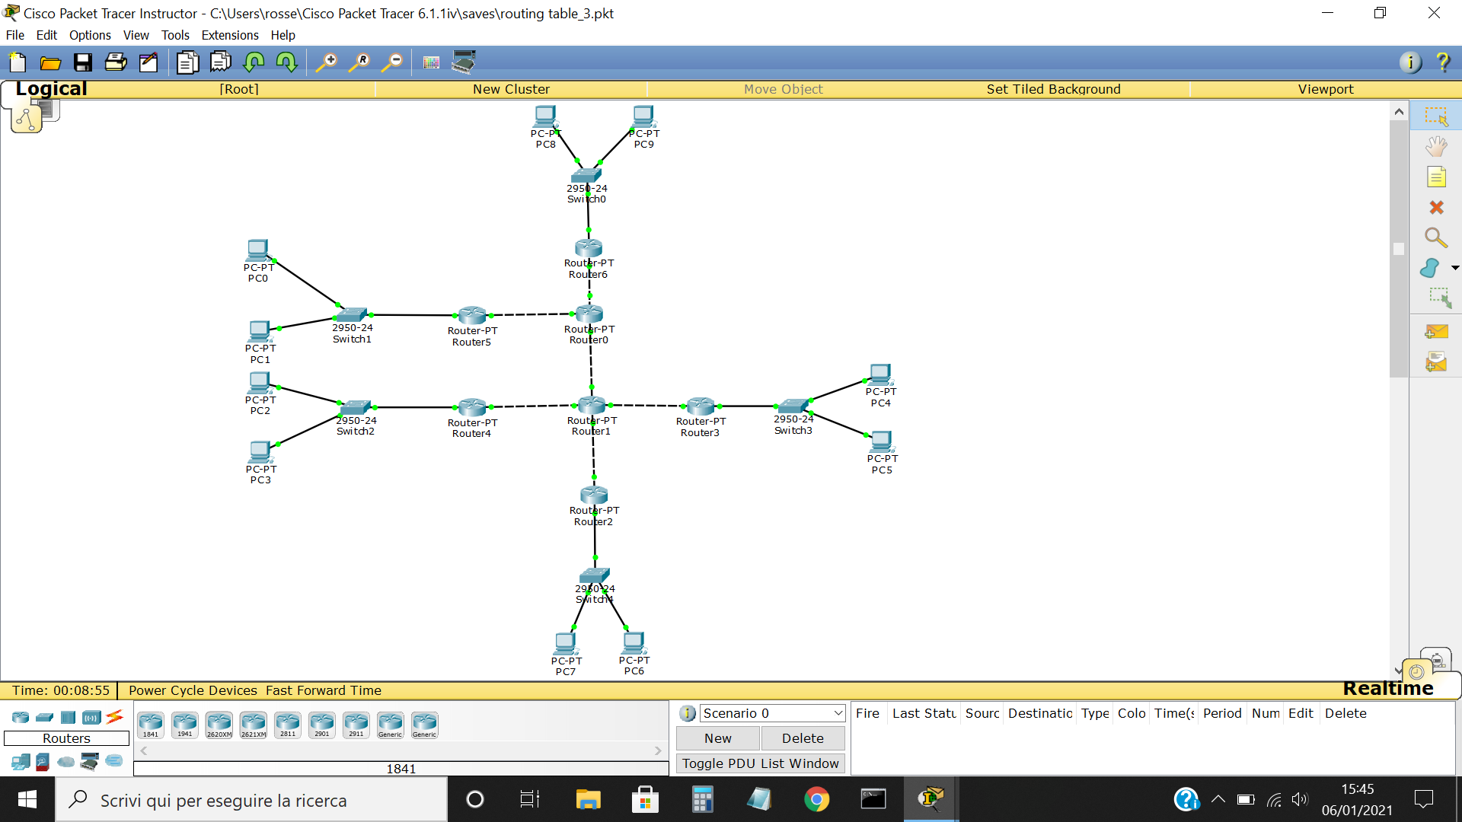

|  |  |  |
| --- | --- | --- |
| **Router** | **Interfaccia** | **IP Address** |
| Router 0 |  |  |
| Router 1 |  |  |
| Router 2 |  |  |
| Router 3 |  |  |
| Router 4 |  |  |
| Router 5 |  |  |
| Router 6 |  |  |

|  |  |  |
| --- | --- | --- |
| **PC** | **IP Address** | **Gateway** |
| PC0 | 192.168.0.1 | 192.168.1.1 |
| PC1 | 192.168.0.2 | 192.168.1.1 |
| PC2 | 192.168.0.3 | 192.168.2.1 |
| PC3 | 192.168.0.4 | 192.168.2.1 |
| PC4 | 192.168.0.5 | 192.168.3.1 |
| PC5 | 192.168.0.6 | 192.168.3.1 |
| PC6 | 192.168.0.7 | 192.168.4.1 |
| PC7 | 192.168.0.8 | 192.168.4.1 |
| PC8 | 192.168.0.9 | 192.168.5.1 |
| PC9 | 192.168.0.10 | 192.168.5.1 |